Midshipman Training Manual
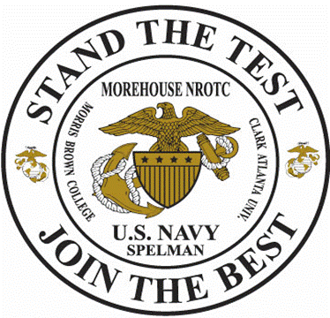

NROTC Atlanta Region

New Student Orientation 2018
Battalion Knowledge
Five Basic Responses
1. Yes, sir/ma’am.
2. No, sir/ma’am.
3. Aye, aye, sir/ma’am.
4. I do not know but will find out, sir/ma’am.
5. No excuse, sir/ma’am.

Responses 1 and 3 are often confused. “Yes, sir/ma’am” is the answer to a question, whereas “aye, aye, sir/ma’am” is used when given an order and means “I understand and will comply.” They are not interchangeable.

Leadership Principles
1. Know yourself and seek self-improvement.
2. Be technically and tactically proficient.
3. Know your followers and look out for their welfare.
4. Keep your followers informed.
5. Set the example.
6. Ensure that the task is understood, supervised, and accomplished.
7. Train your unit as a team.
8. Make sound and timely decisions.
9. Develop a sense of responsibility among your subordinates.
10. Employ your command in accordance with its capabilities.
11. Seek responsibility and take responsibility for your actions.

Leadership Traits (JJ-DID-TIE-BUCKLE)
1. Judgment - The ability to weigh facts and possible solutions on which to base sound decisions.
2. Justice - Giving reward and punishment according to the merits of the case in question. The ability to administer a system of rewards and punishments impartially.
3. Decisiveness - The ability to make decisions promptly and announce them in a clear, forceful manner.
4. Initiative - Taking action in the absence of orders.
5. Dependability - The certainty of proper performance of duty.
6. Tact - The ability to deal with others in a respectful manner.
7. Integrity - The uprightness and soundness of moral principles. The quality of truthfulness and honesty.
8. Endurance - The mental and physical stamina measured by one's ability to withstand pain, fatigue, stress, and hardship.
9. Bearing - The creating of a favorable impression in carriage, appearance, and personal conduct at all times.
10. Unselfishness – Putting the needs of others ahead of one's own comfort and personal advancement.
11. Courage - The mental quality that recognizes fear of danger or criticism, but enables one to proceed in the face of it with calmness and firmness.
12. Knowledge - The understanding of a science or an art. The range of one's information.
13. Loyalty - The quality of faithfulness to country, service, and to your seniors and subordinates.
14. Enthusiasm - The display of sincere interest and exuberance in the
performance of duty.

General Orders
1. Take charge of this post and all government property in view.
2. To walk my post in a military manner, keeping always on the alert and observing everything that takes place within sight or hearing.
3. To report all violations of orders I am instructed to enforce.
4. To repeat all calls from posts more distant from the guardhouse than my own.
5. To quit my post only when properly relieved.
6. To receive, obey, and pass on to the sentry who relieves me, all orders from the Commanding Officer, Officer-of-the-Day, and Officers and non-commissioned Officers of the guard only.
7. To talk to no one except in the line of duty.
8. To give the alarm in case of fire or disorder.
9. To call the corporal of the guard in any case not covered by instructions.
10. To salute all officers, and all colors, and standards not cased.
11. To be especially watchful at night and during the time for challenging, to challenge all persons on or near my post, and to allow no one to pass without proper authority.

Core Values

Honor includes the values of:
· Honesty
· Integrity
· Responsibility

Courage includes the values of:
· Competence
· Teamwork
· Concern (respect) for people

Commitment includes the values of:
· Loyalty
· Patriotism
· Valor

The Salute
1. Do not lean the head in to the salute or forward.
2. Do not salute while uncovered and/or indoors except while you are on duty.
3. Make sure every salute is executed as crisply and perfectly as if in an inspection.
4. Make eye contact with the senior person.
5. Do not interrupt the senior if he/she is in conversation.
6. Do not salute across the street or at a similar distance.
7. Salute officers passing in cars. Do not expect it to be returned, except maybe by a nod of the head.
8. Do not salute at double time pace; slow to quick time, render your salute and greeting, then resume double time after the exchange has been completed.
9. If overtaking a senior, come abreast on his/her left side and say, “By your leave, Sir/Maam?” The senior will reply with “Carry on.” You may then go ahead.
10. Stop and salute the colors upon raising and lowering.
11. If in the company of a senior, you assume his/her rank. Your party may be saluted by other passing personnel. You are to return the person’s salute along with the senior officer. If the person you meet is your senior as well, hold your salute until both officers drop theirs. If your senior is unaware of the junior’s salute, do not embarrass him by returning the junior’s salute. Simply nod in quiet recognition.
12. Salute only with the right hand. Left hand salutes are permitted only in the case of burden or injury to the right hand.
13. If your hands are full, you must still greet your senior in a respectful manner, and he/she will return your greeting with a salute. If his hands are full, you must still greet and salute him/her; he/she will nod and reply appropriately.
14. Do not salute when part of a formation. If an officer is addressing your formation, all hands will come to attention, even if the formation commander neglects the command. If addressed individually in formation, come to attention, but do not salute.
15. Do not salute while seated. If you have civilian companions with you, it is not necessary for them to rise.
16. While you are in uniform, active duty officers in civilian attire should be saluted, while midshipmen officers in civilian attire should not be.
17. Congressional Medal of Honor recipients are always saluted first, regardless of rank.
18. Salute all officers of other United States Armed Forces and friendly militaries, the President of the United States, Vice President, Secretary of Defense, State Governors, Senators, Congressmen, all Secretaries of the Armed Forces, retired officers, foreign Heads of State, and Ambassadors.
19. When rendering a salute raise your right hand smartly in the most direct manner until the tip of your forefinger touches the lower part of the headdress above and slightly right of your right eye. Your fingers should be extended straight and joined with the thumb along the forefinger. You should be able to see your entire palm when looking straight ahead. Your upper arm should be parallel with the deck with the elbow in line with the body and your forearm at a 45-degree angle. Your wrist and hand should be straight, a continuation of the line made by your forearm. See figure 1-1.

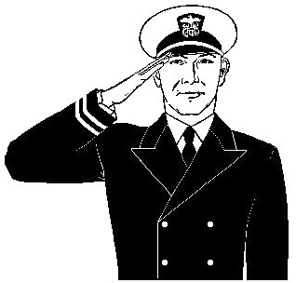

Figure 1-1

All ROTC midshipmen salute senior midshipmen while in uniform. ROTC midshipmen in uniform must also salute all commissioned officers – even if the officer is not in uniform.

Phonetic Alphabet
Alpha November
Bravo Oscar
Charlie Papa
Delta Quebec
Echo Romeo
Foxtrot Sierra
Golf Tango
Hotel Uniform
India Victor
Juliet Whiskey
Kilo X-ray
Lima Yankee
Mike Zulu

Military Leadership

Joint Chiefs:
-Chairman of the Joint Chiefs of Staff | Gen Joseph F. Dunford, USMC
-Vice Chairman of the Joint Chiefs of Staff | Gen Paul J. Selva, USAF
-Chief of Naval Operations | ADM John M. Richardson, USN
-Commandant of the Marine Corps | Gen Robert B. Neller, USMC
-Air Force Chief of Staff | Gen David L. Goldfein, USAF
-Army Chief of Staff | Gen Mark A. Milley, USA

Chain of Command:

-President | Hon. Donald Trump
-Secretary of Defense | Hon. James Mattis
-Secretary of the Navy | Hon. Richard Spencer
-Chief of Naval Operations | ADM John M. Richardson, USN
-Commander, NETC | RADM Kyle J. Cozad, USN
-Commander, NSTC | RDML Mike Bernacchi, USN
-CO, Atlanta NROTC | CAPT Baron Reinhold, USN
-XO, Atlanta NROTC | LtCol Keith Moore, USMC

Miscellaneous:
-Master Chief Petty Officer of the Navy MCPON Steven S. Giordano, USN
-Sergeant Major of the Marine Corps SgtMaj Ronald L. Green, USMC

Facts
-1st CO of GTNROTCU CDR London
-Navy Birthday 13 October 1775
-USMC Birthday 10 November 1775
-Grand Old Man of the Marine Corps Archibald Henderson
-Oldest Ship in the US Navy USS Constitution
-GT Unit founded 1926
-First 6 NROTC Units University of California at Berkeley
Georgia Institute of Technology
Northwestern University
University of Washington
Harvard University
Yale University

Midshipman Honor Code
A midshipman does not lie, cheat or steal.

The Sailors' Creed
I am a United States Sailor. I will support and defend the Constitution of the United States of America and I will obey the orders of those appointed over me. I represent the fighting spirit of the Navy and those who have gone before me to defend freedom and democracy around the world. I proudly serve my country's Navy combat team with Honor, Courage and Commitment. I am committed to excellence and the fair treatment of all.
Code of Conduct
1. I am an American fighting in the forces which guard my country and our way of life. I am prepared to give my life in their defense.
2. I will never surrender of my own free will. If I am in command, I will never surrender the members of my command while they still have the means to resist.
3. If I am captured, I will continue to resist by all means available. I will make every effort to escape and aid others to escape. I will accept neither parole nor special favors from the enemy.
4. If I become a prisoner of war, I will keep faith with my fellow prisoners. I will give no information nor take part in any action which might be harmful to my comrades. If I am senior, I will take command. If not, I will obey the lawful orders of those appointed over me and will back them up in every way.
5. When questioned, should I become a prisoner of war, I am required to give name, rank, service number, and date of birth. I will evade answering further questions to the utmost of my ability. I will make no oral or written statements disloyal to my country and its allies or harmful to their cause.
6. I will never forget that I am an American, fighting for freedom, responsible for my actions, and dedicated to the principles which made my country free. I will trust in my God and in the United States of America.

Anchors Aweigh
Stand Navy out to sea, Fight our Battle Cry;
We'll never change our course, So Army you steer shy-y-y-y.
Roll out the TNT, Anchors Aweigh. Sail on to Victory
And sink their bones to Davy Jones, Hooray!

Anchors Aweigh, my boys, Anchors Aweigh.
Farewell to college joys, We sail at break of day-ay-ay-ay.
Through our last night on shore, Drink to the foam,
Until we meet once more. Here's wishing you a happy voyage home.

Blue of the Mighty Deep; Gold of God's Sun
Let these colors be till all of time be done, done, done,
On seven seas we learn Navy's stern call:
Faith, Courage, Service true, with Honor, Over Honor, Over All.

Marines Hymn

From the Halls of Montezuma
To the shores of Tripoli;
We fight our country's battles
In the air, on land, and sea;
First to fight for right and freedom
And to keep our honor clean;
We are proud to claim the title
Of United States Marine.

Our flag's unfurled to every breeze
From dawn to setting sun;
We have fought in every clime and place
Where we could take a gun;
In the snow of far-off Northern lands
And in sunny tropic scenes,
You will find us always on the job
The United States Marines.

Here's health to you and to our Corps
Which we are proud to serve;
In many a strife we've fought for life
And never lost our nerve.
If the Army and the Navy
Ever look on Heaven's scenes,
They will find the streets are guarded
By United States Marines.
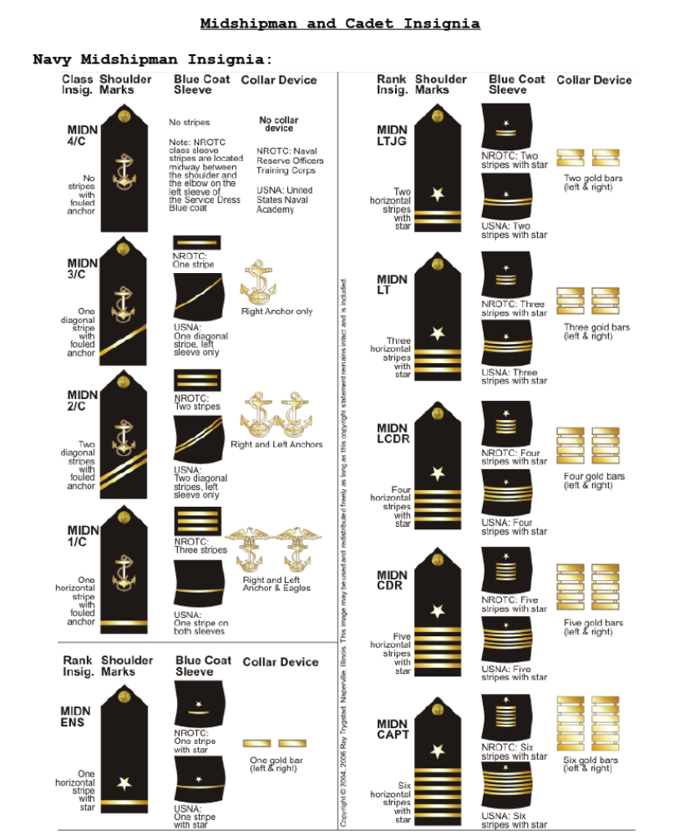

Midshipman and Cadet Insignia
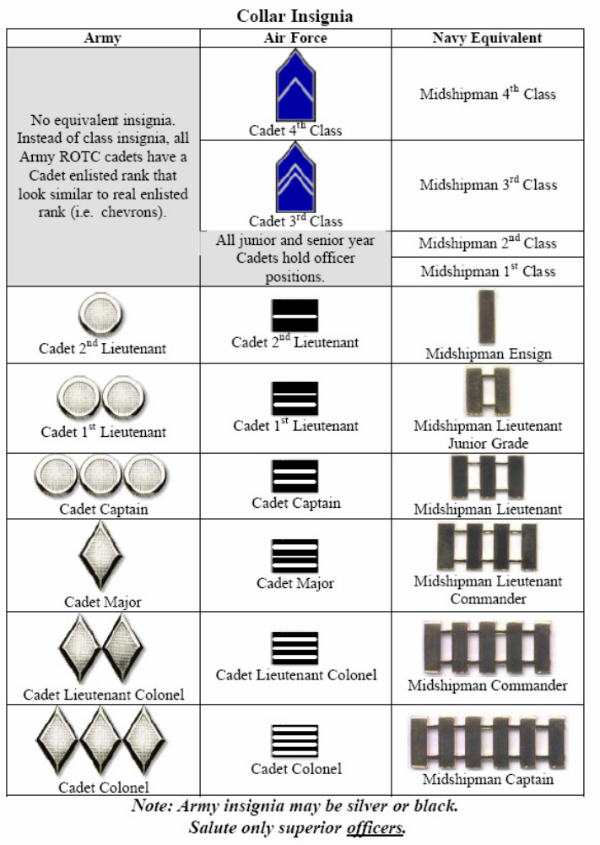
Enlisted Rank Structure
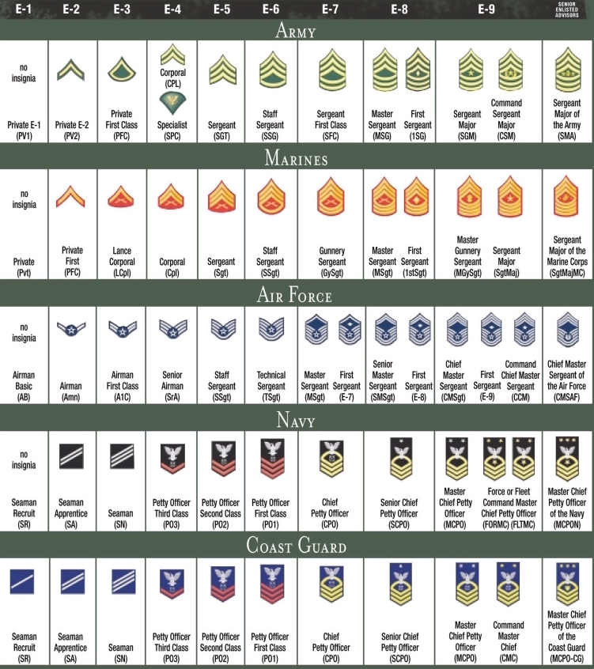

Officer Rank Structure


